TECPEL CO., LTD. Model: HP-100
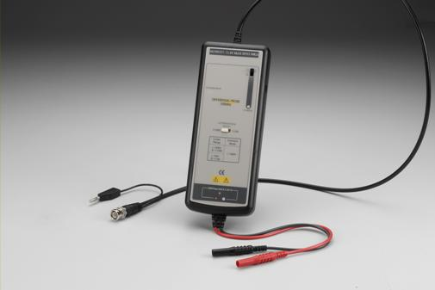
Bandwidth | DC to 100MHz (-3dB)
Attenuation | 1:100/1000
Accuracy | +/- 2%
Rise Time | 3.5ns
Input Impedance | 4Mohm//7pF each side to ground
Input Voltage
-Max. Differential* | ±140V(DC + Peak AC) @ 1/100  ±1400V (DC + Peak AC) @ 1/1000
- Common Mode Range* | ±1400V (DC + Peak AC) @ 1/100 & 1/1000
- Absolute Max. Voltage*  (Differential or Common Mode) | ±1400V (DC + Peak AC) @ 1/100 & 1/1000
Output Voltage
- Swing (into 50kohm load) | ±1.4V
-Offset (typical) | <+/-5mV
-Noise (typical) | 0.6mVrms
-Source Impedance (typical) | 50 ohm
CMRR (typical) | -80dB@60Hz; -50db@1MHz
Ambient Operating Temperature | -10 to 40 degree centigrade
Ambient Storage Temperature | -30 to 70 degree centigrade
Ambient Operating Humidity | 25 to 85% RH
Ambient Storage Humidity | 25 to 85% RH
Power Requirements
-Standard | 4xAA cells or 6VDC/200mA mains adaptor**  or regualted 9VDC/120mA mains adaptor
-Options | Power leads
Length of Input Leads | 30cm
Length of BNC Cable | 90cm
Weight | 500gms
Dimension (LxWxH) | 207mmx83mmx38mm

* Voltage limit is the lesser of the DC+Peak AC and RMS values..
** a. The supplied voltage must be less than 12V and greater than 4.4V, otherwise the probe could be damaged or can't be operated properly.
b. polarity is “+” inside and “–” outside. For wrong polarity, built-in circuit protects the probe, no danger or damage will occur.
c. When the voltage of the cells become too low, the power indicator on the panel will flicker.

TECPEL CO., LTD. Model: HP-025
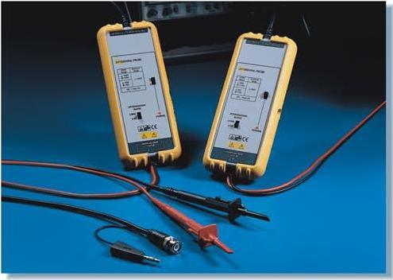
Bandwidth | DC to 25MHz (-3dB)
Attenuation Ratio | 1:20/200
Accuracy | +/- 2%
Rise Time | 14ns
Input Impedance | 4Mohm//5.5pF each side ground
Input Voltage
-Differential Range* | +/-140V(DC+Peak AC) or 140Vrms @1/20  +/-1400V(DC+Peak AC) or 1000Vrms @1/200
- Common Mode Range* | +/-1400V(DC+Peak AC) or 1000Vrms @1/20 & 1/200
- Absolute Max. Voltage*  (Differential or Common Mode | +/-1400V(DC+Peak AC) or 1000Vrms CAT III @1/20 & 1/200
Output
- Swing (into 2k ohm load) | +/-7V
-Offset (typical) | <+/-5mV
-Noise (typical) | 0.7mVrms
-Source Impedance (typical) | 1 ohm @1kHz, 8 ohm @1MHz
CMRR (typical) | -80dB@50Hz,-60dB@20kHz
Ambient Operating Temperature | -10 to 40 degree centigrade
Ambient Storage Temperature | -30 to 70 degree centigrade
Ambient Operating Humidity | 25 to 85% RH
Ambient Storage Humidity | 25 to 85% RH
Power Requirements
-Standard | 4xAA cells or 6VDC/60mA mains adaptor**  or regualted 9VDC/40mA mains adaptor**
-Options | Power leads
Length of BNC Cable | 95cm
Length of Input Leads | 45cm
Weight | 400gms (probe and PVC jacket)
Dimensions(LxWxH) | 170mm x 63mm x 21mm

* Voltage limit is the lesser of the DC+Peak AC and RMS values..
** a. The supplied voltage must be less than 12V and greater than 4.4V, otherwise the probe could be damaged or can’t be operated properly.
b. polarity is “+” inside and “–” outside. For wrong polarity, built-in circuit protects the probe, no danger or damage will occur.
c. When the voltage of the cells become too low, the power indicator on the panel will flicker.

TECPEL CO., LTD.
No. 13, Alley 5, Lane 31, Chung_Teh Street,
Taipei, Taiwan, R. O. C.
Tel: 886-2-2737-5866 ; Fax: 886-2-2737-3343
E-mail: sales@tecpel.com
Web: http://www.oka.com.tw ; http://www.tecpel.com/

